**Effect of Tilt Angle Variation on the Performance of the Flat Collector Solar Thermal System (Passive Type)**

Cheku Dorji*1, Prakash Luitel2, Saran Kumar Gurung3, Tshering Samdrup4

Electrical Engineering, College of Science and Technology, Royal university Bhutan,

E-mail: [chekudorji.cst@rub.edu.bt*1](mailto:chekudorji.cst@rub.edu.bt*1) , [luitelprakash68@gmail.com2](mailto:luitelprakash68@gmail.com2), [saranbee4664@gmail.com3](mailto:saranbee4664@gmail.com3)

**Abstract**

The study demonstrates the importance of proper design and installation of a passive solar thermal system and the need to consider the appropriate collector tilt angle for optimal thermal performance. The experimental setup consisted of a 200-liter passive system installed alongside with an existing 500-liter active thermal system, enabling a solar hot water capacity of 700 liters. The temperature of the flat-type collector outlet and inlet, hot tank outlet, and ambient temper-ature were recorded using temperature sensor data loggers, while solar irradiance was measured using a pyranometer placed on the collector surface. Four system metrics, namely collector effi-ciency, thermal efficiency, heat loss, and mass flow at different tilt angles, were studied. The thermal performance of the system improves with a steady change in solar irradiation when the collector is placed between the tilt angle of 25° and 30°. However, when the tilt angle is increased above 30 degrees, the system efficiency decreases. The thermal efficiency of 60-70% can be obtained at a collector angle of 20° to 30° at the daily solar irradiance of 300 to 900 W/m². Furthermore, the experiment emphasizes the importance of timely draining out of hot water from the system. This practice helps maintain the system's efficiency and sustainability.

***Key Words:*** *Solar water heater, flat collector, tilt angle, thermal efficiency, flowrate, and heat loss*

1. **INTRODUCTION**

Bhutan has a diverse climate, ranging from subtropical in the southern foothills to temperate in the north. This change in climate makes it easier for people to use renewable energy sources such as wind, solar, biogas, and hydropower. Bhutan re-ceives global solar irradiance of 4 kWh/m2 daily and the clear sky in almost all seasons makes it feasible for the implementation of solar thermal technology for lighting, heating, and ventilation (Rinzin, N., Choden, Y. & Delkar, C. 2019).

As per International Hydropower Association Bhutan can generate about 30,000MW, according to the International Hydropower Association, of which 23,760MW has been listed as economically feasible. With the completion of the Mangdechhu Plant in 2019, the total installed capacity has risen to 2326 MW, with 70% of the capacity going to India, which accounts for 27% of government revenue and 14% of GDP (Hydro-power Status Report, 2016).

However, because of global warming and climate change, relying entirely on hydropower as a primary energy source is not sustainable. With the inception of the Alternative Renewable Policy in 2013, Bhutan has set a target of generating 20 MW of renewable energy sources (RE) by 2025 (Dorjee and Ugen, 2009). In 2016, Bhutan installed a pair of 600kW wind turbines in Rubesa village, WangduePhodrang, which served 150 households. The project was funded by the Asian Development Bank (Kharka, 2016).

Since solar energy is abundant, it can be transformed into heat and light with the help of technology. In rural areas of Bhutan, firewood is the primary source of heat, while urban depend mainly on electricity and fossil fuels. Therefore, harnessing solar energy has the potential to supplement the already scarce and depleting supply of firewood and fossil fuels (Bennewitz & Persson, 2016).

As part of an undergrad project a 500-liter tank capacity of active prototype solar water heating (SWH) system was fabricated and installed at the College Mess in 2019. The hot water delivered by the system is directly used for cooking the students' meals (businessbhutan.bt/2019/03/27).

In this paper, an additional 200 liter of ther-mosiphon-based passive type SWH with an ad-justable tilt angle of 20 to 50 degrees is established to carry out the effect of collector angle on the performance of the system.

1. **THE SOLAR THERMAL SYSTEM**

Solar water heating is the simplest way to heat water using the sun's energy. The system is usually installed on a roof or open ground, with the col-lector facing the sun and connected to a continuous flow of water.

The collector collects solar radiation, and the absorber transfers the energy to the fluid that flows through the collector tubes. The heated water rises to the top level of the storage tank. A continuous flow of water circulating from the tank to the col-lector is required as shown in Figure 1. The hot water is drawn from the top, and an equal volume of cold-water flows into the bottom of the tubes. It does not need a pump or a controller, unlike an active thermal system. The cold water is naturally drawn through the collector tubes when hot water is drawn from the hot tank outlet (Ogueke, 2009).

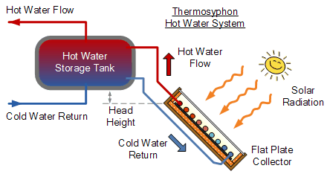

Fig.1: Thermosyphon system

([*https://www.alternative-energy-tutorials.com/solar-hot-water/flat-plate-collector.html*](https://www.alternative-energy-tutorials.com/solar-hot-water/flat-plate-collector.html)*)*

* 1. **The Installation of the SWH System**

The prototype for the experiment was set up nearby the student’s kitchen at a location of 26° 51' 6'' North and 89° 23' 4'' east based on the sun path. The 200-liter horizontal tank with open loop circulation has a double-glazed collector area of 2.8 m x 1.1 m, positioned with the adjustable tilt angle as shown in Figure 2.

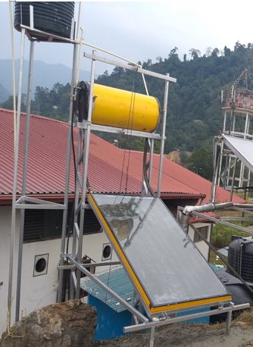

Fig. 2: The setup of the SWH Prototype

* 1. **The Measurement and Data Analysis**

The experiment was conducted over two weeks by varying the collector tilt angle from 20° to 45° at the step five. The hot water was drained out every afternoon and refilled for the next day. The temperatures of the collector outlet and inlet, hot tank outlet, and ambient temperature are all rec-orded using a k-type thermocouple sensor as shown in Figure 3.

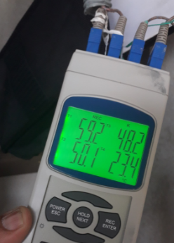

Fig. 3: Temperature data logger

The measurement of a clear sunny day was used for the performance analysis of the installed system. Solar irradiance was nearly constant while tracking system temperatures at different tilt angles as shown in Figure 4. The solar data for a one-minute sample rate is collected from the ground station, a pyranometer mounted on the rooftop at 12°.



Fig.4: Daily average solar irradiance at the site

The temperature of the collector, tank outlet, and inlet were logged for every change in collector angle and compared against daily solar irradiance as shown in Figure 5. It is observed that the maximum temperature or thermal stratification could be achieved between 10 a.m. and 1 p.m.

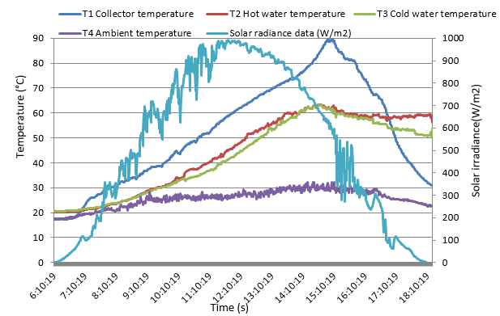

Fig.5: System Temperatures at 30° angle.

* 1. **Daily Water Usage Pattern**

It is important note that timely draining out of hot water every day could avoid thermal stratification and loss of system efficiency. In this case, the hot water is drained twice a day, at 10 a.m. and 3 p.m. The temperature of the hot water is examined for every change in collector angle, and it varies with the consumption pattern**.**

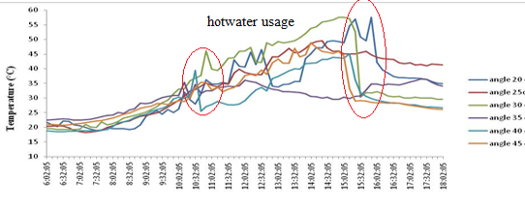

Fig .6: Daily Water usage profile

From above Figure 6, it is seen that any delay in draining out in the morning would affect the rate of rise of temperature in the afternoon since it is de-pendent on the solar irradiance which falls gradu-ally in the afternoon.

* 1. **Tilt Angle Effect on Thermal Efficiency and Losses**

There is no significant change in the collector efficiency however, the thermal performance of the system is greatly influenced by the tilt angle vari-ation. The system efficiency is defined as the ratio of solar energy yield to the solar irradiance of the system over a given time computed by the fol-lowing equation (Rinzin, N., Choden, Y. & Delkar, C. 2019).

ƞ = Q/ (A×I)

where

Q-mass of heat requirement

Q = ρV×cp× (Tevening- Tmorning)

ρ = 1 kg/m3, water density

V= 200L, volume of the tank

Cp= calorific value of water, 4186J/kg/K

Tevening- Tmorning, hot water temperature difference

Figure 7 illustrates how the system (thermal) efficiency increases as average solar irradiance rise steadily for collector angles of 25° to 30°. As the tilt angle exceeds 30 degrees, however, thermal losses begin to increase significantly, despite increased solar irradiance.

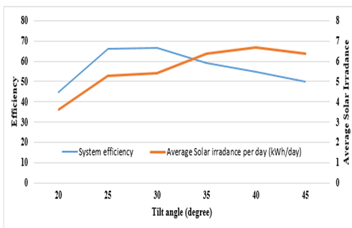

Fig.7: Thermal Efficiency with change in tilt angle

* 1. **Tilt Angle Effect on mass flow rate and**

**Collector**

The optimum flow rate of the system is de-termined based on the collector area, solar irradi-ance, and temperature difference between the col-lector's outlet and inlet (Prakasam, et al, 2017). The flow rate for the installed system was found to be 1.14 L per minute, and it closely followed the solar energy pattern, but it lags whenever the hot water is drained out as seen in Figure 8.

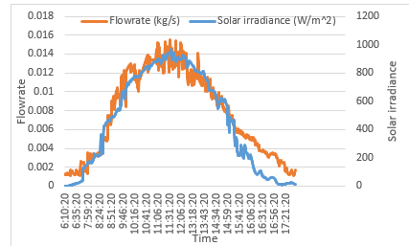

Fig.8: the variation of flow rate with solar irradiance

1. **CONCLUSION**

In conclusion, the installation of the passive SWH (solar water heating) prototype at the CST campus marks a significant milestone in the advancement of solar thermal technology. This prototype serves as a platform for research, training, and practical implementation of solar thermal systems.

The experiment conducted on the prototype has provided valuable insights regarding the optimal inclination angle for the solar collector. The results indicate that the system's overall efficiency is highest when the collector is inclined at an angle between 20° to 30°. This finding suggests that the collector should be installed within this range to maximize its energy capture capability.

Additionally, the study reveals that while the efficiency of the collector itself is not greatly impacted by changes in the inclination angle, the thermal efficiency of the system undergoes significant variations. As the inclination angle surpasses 30°, thermal losses become more prominent, resulting in a decrease in thermal efficiency. Therefore, it is important to consider the optimal inclination angle to achieve the desired thermal performance.

Furthermore, the experiment emphasizes the importance of timely draining out of hot water from the system. This practice helps maintain the system's efficiency and sustainability.

**REFERENCES**

A., S., & Kalogirou. (2009). *Solar Water Hearing System.* Solar energy Engineering.

Dorjee, P., & Ugen. (2009). Renewable energy in Bhutan. *Overview of Renewable Energy Projects*.

Eze, J. I. (2012). *Passive solar water heating.*

Gong, J., & Sumathy, K. (2016). *Active solar water heating system.*

Hudon, K. (2014). *Solar energy- Water Heating.* Future Engineer.

Hydropower Status Report. (2016). *Hydropower*.

Kharka, K. (2016). Bhutan gets its first wind turbines.

Ogueke.N.V, A. E. (2009). Journal of Renewable and Sustainable Energy. *A review of solar water heating systems.*, 1-21.

Ojike, O. (2012). *Passive solar water heating.*

*Planning and Installing Solar Thermal System.* (2010). London: Earthscan.

Rinzin, N., Choden, Y. & Delkar, C. (2019). Design, Installation And Performance Analysis Of Solar Water Heating System In Cst Kitchen.*.*

Prakasam, M. J. S. et al (2017)An Experimental Study of the Mass Flow Rates … THERMAL SCIENCE, the Year 2017, Vol. 21, Suppl. 2, pp. S379-S388

CST students come up with three new projects. Retrieved from https://businessbhutan.bt/2019/03/27/cst-students-come-up-with-three-new-projects/

Peter Bennewitz & Johan Persson (2016) Solar Thermal Energy In Thimphu, Bhutan, A feasibility study using TRNSYS modeling. Retrieved from https://lup.lub.lu.se/student papers/reord/8830458/file/8830459.pdf